# Experiment Name: Implementation of Shortest-Job-First (SJR) non-preemptive scheduling algorithm.

**Objectives:** To learn about Shortest-Job-First (SJR) non-preemptive scheduling algorithm. Implement Shortest-Job-First (SJR) non-preemptive scheduling algorithm by using c program. And testing the program in different input and find output.

**Code:**

#include <stdio.h>

int main()

{

int i,j,a[10],b[10],temp[10],temp1,avg=0,tt=0,n;

printf("enter the number of Processes:\n");

scanf("%d",&n);

printf("enter arrival time\n");

for(i=0;i<n;i++)

scanf("%d",&a[i]);

printf("enter burst time\n");

for(i=0;i<n;i++)

scanf("%d",&b[i]);

for(i=1;i<n;i++)

for(j=1;j<n;j++)

if(b[j]>b[j+1])

{

temp1=b[j];

b[j]=b[j+1];

b[j+1]=temp1;

}

temp[0]=0;

for(i=0;i<n;i++)

temp[i+1]=temp[i]+b[i];

printf("\nGantt Chart\n");

for(i=0;i<n+1;i++)

printf("\n%d",temp[i]);

for(i=1;i<n;i++)

avg=avg+temp[i]-a[i];

avg=avg/n;

printf("\nThe Average WT is %d ms",avg);

for(i=2;i<n+1;i++)

tt=tt+temp[i]-a[i-1];

tt+=temp[1];

tt=tt/n;

printf("\nThe Average TT is %d ms",tt);

return 0;

}

**Output:**

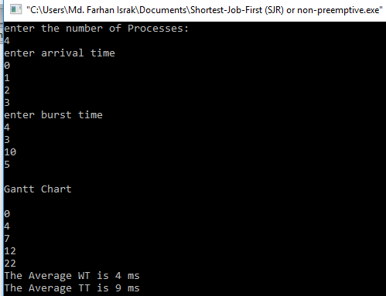

**Discussion:** Shortest job first (SJF) is a scheduling policy that selects the waiting process with the smallest execution time to execute next. SJF is a non-preemptive algorithm. Shortest Job first has the advantage of having minimum average waiting time among all scheduling algorithms.